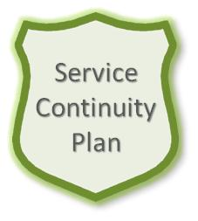
author(s) : Suhas Jadhav
For internal use
Service Continuity Plan (SCP) for Managed Public Cloud AWS
document number : MSD-S67-0001
version : 1.0
status : Final
source : Atos
document date : 09 April2020
number of pages : 27

Role | Names, Dates, Signatures
Reviewers | Izabela Klimczak | 26/04/2019
 | Veron van Beuningen
 | Hubert Fischbach
Quality Assurance Function | Andrada Badea
Document Owner | Diana Asnani
Senior Manager Atos | Radek Klicki

© Copyright 2015, Atos International Germany All rights reserved. Reproduction in whole or in part is prohibited without the prior written consent of the copyright owner. For any questions or remarks on this document, please contact Atos, +.
Contents
1 About this document 5
1.1 Owner 5
1.2 References and further applicable documents 5
1.3 Glossary 5
1.4 Reviews and review cycle 6
1.5 Filing of this document 6
1.6 Distribution 6
2 Introduction 7
2.1 Description and Purpose 7
2.2 Plan Administration and Usage / Applicability 8
2.3 Confidentiality 9
2.4 Assumptions and dependencies 9
2.5 Roles and responsibilities 9
2.5.1 Document Owner 10
2.5.2 Disaster Recovery Coordinator (DRC) 10
2.5.3 Disaster Recovery Team (DRT) 10
2.5.4 Major Incident Manager (MIM) 10
2.5.5 Account Service Team (AST) 10
2.5.6 Service Delivery Manager (SDM) 11
2.5.7 Tower Service Manager (TSM) 11
3 Prevention 12
3.1 Requirements, strategy and risk reducing measures 12
3.1.1 Requirements 12
3.1.2 Continuity Strategy 12
3.1.3 Risk Reducing Measures 14
3.1.4 Capacity Planning 14
3.2 Training 14
3.3 Maintenance 14
3.4 Disaster Recovery Tests 15
3.5 Audits, Reviews and Assessments 15
4 Immediate actions 16
4.1 Prioritization 16
4.2 Handling procedures 16
4.3 Alerting and escalation 16
4.4 Checklist Service Responsible Manager (Manager on Duty) 16
4.5 Invocation 17
5 Disaster Management 18
5.1 Managerial Responsibilities 18
5.2 Checklist Disaster Recovery Coordinator (DRC) 18
5.3 DR office / DR conference bridge 18
5.4 Recovery team 18
5.4.1 Members of the team 18
5.4.2 Service Delivery Manager (SDM) 18
5.5 Disaster Scenarios 19
5.6 Recovery Options 19
5.7 Prioritization 19
6 Customer overview and details 20
7 Recovery Procedures 21
7.1 Prerequisites before the start of the recovery procedures 21
7.2 Recovery of service 21
7.3 Recovery of tools 21
7.4 Recovery of processes 21
7.5 Recovery of staff 21
7.6 Actions after the recovery procedures 21
8 Suppliers 22
9 Post Processing 23
9.1 Root cause analysis 23
9.2 Lessons Learnt 23
9.3 Disaster Report 23
10 Glossary 24
11 Appendices 25
11.1 A Prevention 25
11.2 Appendix B Immediate actions 25
11.3 Appendix C Disaster Management 25
11.4 Appendix D Client Overview 25
11.5 Appendix E Recovery Procedures 25
11.6 Appendix F Suppliers 25

List of changes
Version | Date | Description | Author(s)
0.1 | 18-Nov-2016 | Draft version | Izabela Mlodzianowska
0.2 | 30-Aug-2017 | Change from MS to ORGANIZATION | Izabela Mlodzianowska
0.3 | 17-May-2018 | Revised with MPC-AWS | Diana Asnani
0.4 | 09-April-2019 | Yearly revision by BCC | Izabela Klimczak
1.1 | 09-Apr-2020 | Yearly Revision by BCC | Magdalena Pierzchalska

Abbreviations
Abbreviation | Description
AST | Account Service Team
ORC | Operational Resilience & Continuity
BCM | Business Continuity Management
BCP | Business Continuity Plan
BIA | Business Impact Analysis
CMT | Crisis Management Team
DRC | Disaster Recovery Coordinator (see SRM)
DRP | Disaster Recovery Plan
DRT | Disaster Recovery Team
EHB | Emergency Handbook
EM | Emergency Matrix
EMC | Enterprise Management Center
GBU | Global Business Unit
HQ | Headquarters
ITSCM | IT Service Continuity Management
CI | Critical Incident
CIM | Critical Incident Manager
MoD | Manager on Duty
ORGANIZATION | Infrastructure and Data Management (Atos Organizational sector)
PcM | Process Manager
RA | Risk Assessment
RCA | Root Cause Analysis
RPO | Recovery Point Objective
RTO | Recover Time Objective
SCP | Service Continuity Plan
SDM | Service Delivery Manager
SLA | Service Level Agreement
SMC | Service Management Center
SMS | Short Message Service
SOM | Service Operations Manager
SRM | Service Responsible Manager actually he is the acting DRC for Cloud Services
SRP | Service Recovery Plan
TEL | Technical Lead
TEX | Technical Expert
TSI | Tower Service Integrator

About this document

Owner

The Service Responsible Manager owns this Service Continuity Plan (SCP) including the master document and all its appendices (document owner).

References and further applicable documents

The Service Continuity Plan is a document which relays and is influenced by other documents which are listed in the following table, including a link.

Document | Type | Relevant for chapter | Issued by | Link to source
MSD-U02-0003 Cloud Services Operations Manual |  | 3.10. | Edwin Kuijpers | MSD-U02-0003
Managed Public Cloud Service Description |  |  |  | https://sp2013.myatos.net/portfolio/ms/Portfolio%20Offerings%20Document%20Library/Managed%20Public%20Cloud_L4D.pptx?Web=1
MSW-S67-XXXX-MPCAWS disaster recovery plan and service continuity
MSD-S67-0030 MPC_AWS Generic Cloud Reference Architecture - VOL2 - Network Connectivity and Options |  |  |  | https://sp2013.myatos.net/ms/gd/services/MPC/MSD-S67-0030%20MPC_AWS%20Generic%20Cloud%20Reference%20Architecture%20-%20VOL2%20-%20Network%20Connectivity%20and%20Options.pdf

Glossary

The general BCM Glossary applies for this document which is available in Sharepoint (see BCM Glossary MSD-BCM-0100 ). The main definitions relevant for this document as well as additional document or location specific definitions are available in chapter 10.

Reviews and review cycle

The owner of this plan as mentioned in chapter 1.1 is responsible that the plan is always up-to-date. Hence this document will be reviewed at least every 12 months or after significant changes in the scope or infrastructure of the covered location, services and clients. The owner of this document is responsible for the planning and execution of these revisions.

Filing of this document

The Master document of this plan is filed in Cloud Services Global Document library for the service. The owner of this document is responsible that the most current version of this document is available via this link at any time.

Distribution

To ensure the implementation of this document in the Organization and to ensure the offline availability, some official copies are distributed to key people as documented (see table below). With each change in the master document, older copies are retracted and replaced by the newest version. At the same the recipients of the copies are revised regarding up-to-dateness and completeness.

Copy | Issued to | Role/Position | Date
001 | Diana Asnani | Tower Service Manager
002 | Izabela Klimczak | BCC for Global Cloud Services
003 | Keith Dixon | Operation Security Officer (OS management)
004 | Dorin Vlas | Operation Security Officer (Infrastructure management)
005 | Suhas Jadhav | Service Responsible Manager

Introduction

Description and Purpose

This Service Continuity Plan (SCP) for service MPC-AWS was developed in Atos Organization in accordance with the valid process for IT Service Continuity Management (ITSCM). The framework for the development of the SCP is given by the Atos Business Continuity Management Policy (MSM-BCM-0110) and the approved Business Continuity Management program for Global Cloud Services.
The SCP is a single module (a single service specific continuity plan) beside other modules in the IT Service Continuity Plan (ITSCP) which is again part of the overall Business Continuity Plan (BCP) for Atos.

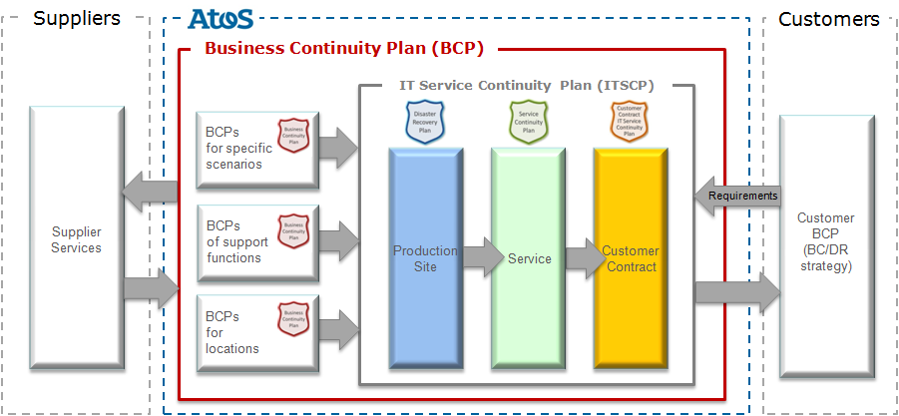

Figure 2.1: Overview and relation of different Continuity Plans

The aim of this document is to support a quick recovery of the Atos Organization services or the rapid transfer of services to an alternate site or platform in order to meet all contractual obligations specified in RTO, RPO, MBCO and MAO.
Due to the modular continuity plan model of Atos Organization this document may not cover all actions necessary in a case of a major business disruption. The nature of this SCP is to describe all actions to be performed. If other areas are affected (e.g. physical damage in a production center), other continuity plans might be invoked as well. The scope of this SCP is defined as follows:

Scope summary:

Service Practices : Cloud Services
Service in scope: Managed Public Cloud AWS
RBU: Global
Data Center locations: Ireland (EMEA)
North Virginia (NAM)
Singapore (NAM)
Production Center: Poland, Netherlands
Customer(s): All MPC-AWS customers

Plan Administration and Usage / Applicability
This Service Continuity Plan aims to assure continuity of a generic service, which is offered to multiple customers and provided from different locations. Continuity requirements are based on general assumptions and common aspects of contracts. In case customer requirements exceed service levels described here, according solutions and procedures have to be developed and need to be agreed with the according service delivery and documented in a customer specific continuity plan.
The Service Continuity Plan (SCP) is a set of documents. Insofar, this document is only the master document which provides the overall description while detailed information and procedures are covered in separate appendices (can also refer to a tool such as a configuration management database CMDB).
The structure of the SCP is shown in Fig 2-2.

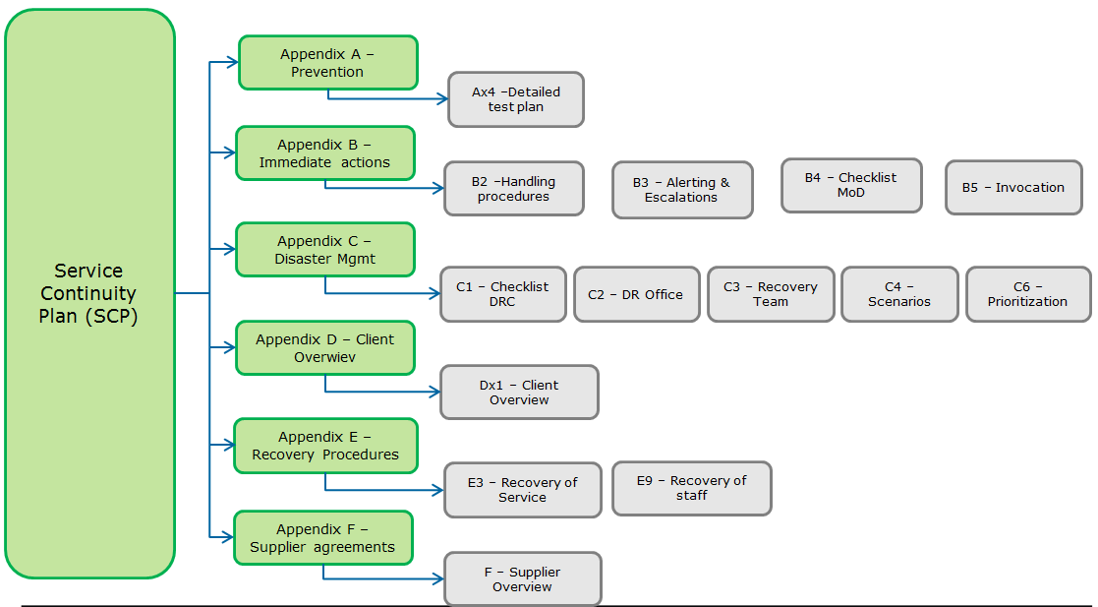

Figure 2-2: Basic structure of SCP

This SCP will be used in case an event which has the potential to become a major business disruption or is identified as a major business disruption, also called a disaster.

Once the Service Continuity Plan has been invoked, services levels and response times are valid as described in appendix D and appendix E.

A disaster and disaster recovery are defined as:

Disaster | A Disaster is a sudden unplanned event that causes great damage or serious loss to an organization. It results in an organization failing to provide critical business functions for some predetermined minimum period of time.
Disaster Recovery | Disaster Recovery or DR is the ability of an Organization to provide critical Information Technology (IT) and telecommunications capabilities and services, after it is disrupted by an incident, emergency or disaster. DR recovers the disrupted IT and telecommunications capabilities to ensure Critical Business Functions can continue within a minimum period of time, pre-determined by the Organization, to planned levels of operations.

Confidentiality
Due to the nature of a SCP, it contains data which should not be shared across clients or with persons outside of Atos. Also, some of the appendices in the SCP, such as critical records and detailed procedures, are protected to secure Atos’ know-how and confidential data. Thus, they shall be only available to the employees who need the information to perform their work during tests and major business disruptions. Any single document has its own classification, must be handled accordingly and need approval from their owner before sharing with other parties than the members of defined access groups.
To ensure that SCPs can be also used as evidence for customers, the master document of the SCP (this document) must not contain any confidential data so that the Owner or the ORC can share a pdf version of the master document with the customer without any additional approval and effort for adaptation.

Assumptions and dependencies

The SCP is defined and expected to work under the following assumptions:

- Critical Incident Management staff is available
- Suitably trained staff available to perform the recoveries.
- Redundant communication links are available.
- Disaster Recovery is contracted for the affected services/clients.
- Current backup media is available and accessible.

Specifically, relevant for MPC-AWS:
- The S3 service from AWS is available where the latest backup are stored
- Other Availability Zones (AZs) are available.

Besides the continuity needs for the service in scope itself, there might be dependencies to other Atos services which are not in focus of this SCP. At one hand there are services being a prerequisite to run the service in scope. At the other hand services rely on the service in scope. These other services and their continuity needs have to be covered by other SCPs (by the service owner for these services).

The following services, infrastructure, tools and processes are identified as prerequisite for the service in scope:
- CIM processes and tools (Comet, Lync) are accessible and active
- An up-to-date Configuration management system is available

Specifically relevant for MPC-AWS:
- Atos SharePoint available (holding Work instructions and Design documents
- ServiceNow and SNOW CMDB are available.
- Atos communication tools

Roles and responsibilities
The following roles and responsibilities describe the key players during the recovery of the services and their basic responsibilities.

Document Owner
The document owner for this Service Continuity Plan (SCP) is responsible that the SCP is developed and implemented, that it contains all information required by the mandatory structure, that it has an approval from senior management and that all documents and information are up-to-date (reviewed at least once a year), tested (at least once a year) and that according people are trained (at least once a year).
The document owner orchestrates this SCP and assigns owners for specific documents and content and addresses them for reviews and updates. All feedback related to the content should be addressed to the document owner who is responsible to use it for continuous improvement of the SCP.
The term document owner is also used for single documents / procedures / appendices where the described responsibility will be applied accordingly.

For Cloud Services the role of Document Owner is the Service Responsible Manager.

Disaster Recovery Coordinator (DRC)
A DRC is nominated as soon as the SCP has been invoked. He leads the Disaster Recovery Team (DRT) and coordinates all activities necessary to reduce the impact of the disaster and to meet specific recovery requirements such as RPO, RTO, MBCO and MAO. He is also responsible to report to the management and to involve and interact with crisis management if necessary. The DRC is the single point of contact to take first decisions and activities needed to reduce the impact of an incident

For Cloud Services the role of DRC is the Service Responsible Manager (or the SRM’s backup).

Disaster Recovery Team (DRT)
Consists of experts for each service involved in a disaster, executes the Service Continuity Plan and make sure that the recovery objectives are met. The team provides advice to the Disaster Recovery Coordinator in terms of selection of recovery options and priorities and sequence of work. Appendix C3 provides a list with experts from different practices in order to set-up a team quick, however, the DRC might change and expand the team as needed.

The Disaster Recovery Team is defined in the Major Incident Management system. The Major Incident Manager can add any employee required.

Critical Incident Manager (CIM)
Any major business disruption is handled by the Critical Incident Manager (CIM) as part of the Major Incident Management Process. The MIM will be responsible for contacting personnel as detailed in the COMET application. The MIM will be responsible for the first steps during a major business disruption or potential a potential major business disruption.

Depending on the complexity and the expected timeline for recovery actions, the CIM will also fulfill the role of the DRC until the DRC is appointed.

For Cloud Services the role of CIM is assigned from the pool of Critical Incident Managers from the Service Management Center.

Account Service Team (AST)
The AST maintains the primary relationship to the customer. In case of disaster, the AST supports the Disaster Recovery Coordinator in terms of providing customer communication. On the proactive part, the AST provides input such as customer requirements and impact to customer business and is therefore responsible to conduct customer oriented BIAs on a regular basis. The AST also escalates risks where customer investment or acceptance is required. The AST is responsible for development, maintenance, testing and execution of customer specific continuity plans, if required by the customer.

Service Delivery Manager (SDM)
The Service Delivery Manager (SDM) is as part of the recovery team responsible for escalating and informing the client of the current situation and keeping them informed of the progress of the recovery process.
The Service Delivery Manager uses the MIM as the single point of contact for the communication path during the recovery process.

Service Delivery Manager is currently part of AST team.

Tower Service Integrator (TSI)
The Tower Service Integrator (TSI) is kept informed about the disaster and is the primary contact from the service towards the Service Delivery Manager.

Prevention

Requirements, strategy and risk reducing measures

Requirements
Requirements for Continuity Management are mainly derived from contractual obligations, Business Impact Analyses (BIAs) and Management expectations.
Key figures determine the requirements to be met during a disaster are listed below
- Recovery Point Objective (RPO)
- Recovery Time Objective (RTO)

The following picture illustrates the key figures:

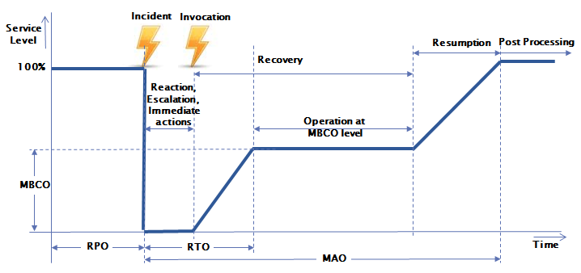

Figure 3-1: Key figures for IT Service Continuity Management

The standard key figures values for the service in scope of this SCP are described in the MSD-S67-0030 MPC_AWS Generic Cloud Reference Architecture - VOL2 - Network Connectivity and Options (See section 5.9.7 where in case of unavailability issues lasting longer than 8 hours’ services will be manually restarted in the other AZ (This assumes that the other AZ is available. In case of a Region failure all customer workload is not available either so there is nothing to manage/monitor, all we can do is wait until AWS recovers.). The service levels measured for the RTO is 12 hours and the RPO is 24 hours.)

Continuity Strategy
Based on the results of BIAs and BCM Risk Assessments a strategy has been developed for the service in scope, giving answers how requirements can be met and how the impact of disasters can be avoided or reduced. Following the overall continuity strategy, the adaptation for the specific needs of the area of application is described below.

The continuity strategy for MPC-AWS is limited to the scope of the tooling environment where the service availability is 99.9%. Customer DR is out of scope for the MPC-AWS service. The MPC tooling environment is hosted in the Amazon Data Centers in Ireland, North Virginia and Singapore. These data centers are highly reliable and highly available with uptime of 99.99%.

In case of a regional or availability zone failure which impacts the MPC tooling environment, the impact is limited to:
- no monitoring (no immediate customer impact, but the operations team will not see new issues)
- no backup/restore (direct impact in case customer wants to restore)
- no AWS resource provisioning and discovery from the CMP portal (direct impact to the customer).

In a regional failure, all availability zones in that region will not be available. We are not able to do anything other than wait until AWS recovers. However, in the event of an availability zone failure, we are able to restore the MPC tooling environment manually in the standby availability zone.

CPM is the instance snapshot backup solution from MPC and should be restored first as some other services can rely on it. For CPM recovery, we will redeploy a new CPM instance manually using the latest snapshot available for CPM data volume using existing CloudFormation Stack. A EBS snapshot is constrained to the region where it was created and is not affected by a AZ loss.

The ServiceNow MID servers are used to perform AWS resource provisioning from the CMP portal and two modes of monitoring which are agentless OS monitoring and AWS cloudwatch monitoring. For the MID servers recovery, we will recover the MID server instance manually using the latest snapshot available from the CPM server. Additionally, we will also have to communicate to the tooling team to reconfigure the monitoring objects in SNOW and any configuration in SNOW for the CMP portal

Forward proxy allows communication to the Internet using FTP/HHTP/HTTPS protocols from the tooling private subnets where the stepping stones are deployed. It is deployed in an Auto Scaling Group with min max set to 1. In case of EC2 healthcheck failure, new instance will be deployed automatically in second AZ without manual intervention. EIP address assigned to the instance will be associated with the new host.

For each region, there are two Active Directory servers deployed in different AZs for HA. AD servers are placed in Shared Service subnets. AD service is fault tolerant globally, as it is replicated to 3 Regions. In scenario of manual recovery is required, restore AD server from a snapshot similarly like other services.

The application aware backup solution from MPC consists of the Networker Server, NMC Server, Cloudboost appliance and additional Storage Node(s). The Networker Server is a collection of processes and programs that are installed on a host that performs Networker services. The NMC Server manages all Networker Servers and Clients. The CloudBoost appliance is a low cost tape replacement solution which enables backups to the public cloud storage. CloudBoost appliances and Storage Nodes are placed in the same VPC as the customer workload EC2 instances – backup clients.

For the Networker and Networker NMC server recovery, we will recover the Networker server instance manually using the latest snapshot available from the CPM console. Additionally, there are other manual configurations that has to be done such as configuring the hostfile in the Networker server and recreate connections to the clients. The OS team will have to update all the hostfile on all clients with the new Networker server IP. The recovery of the storage node is also similar as the Networker server. To recover the Cloudboost appliance, we will create the AMI from the latest snapshot and create a new cloudboost instance from the AMI. Additionally there are other manual configurations such as configure the hostfile, recreate the connections and updated the hostfile on clients (to be done by the OS team)

The OS and application management servers are also deployed in different AZs for HA. In scenario of manual recovery is required, restore the servers from a snapshot similarly like other services.

Since a strategy can be followed on different ways, Recovery Options are defined as described in chapter 5.6.

Risk Reducing Measures
Based on the defined continuity strategy, best practices, results from regular risk assessments and lessons learnt from DR Tests as well as real disasters, a number of measures are already implemented in the design of the service in scope. These measures are either intended to avoid the occurrence of a disaster or at least reduce its impact.

The following risk reducing measures are included in the solution design of MPC-AWS service:

- MPC design tooling principles
  - redundant Networks
  - redundant connectivity
  - the tooling VPC will be multi-AZ
  - Recovery of Tooling VPC requires manual rebuild from snapshots in the standby AZ.

  - DR execution Plans
- AWS Data Center contract is in place
- Analysis of received capacity threshold alerts, monitor capacity trending metrics of the backup and monitoring systems
- A comprehensive backup and recovery scheme

Details about the implemented risk reducing measures are described in the DR design for the MPC-AWS service.

Capacity Planning
In order to cope with disasters, sufficient capacity must be available to fulfill contracted requirements. This includes both staff levels as well as infrastructure capacity, during all phases
- Staffing and infrastructure for proactive continuity management
- Additional staff on call during normal operations
- Sufficient staff and infrastructure capacity for disaster recovery
Details about available and planned capacity can be found in the Operational Capacity Report for the MPC-AWS service
Note: In many services DR is an option which the customer can choose per VM. The installed capacity will not include VMs for which the customer has not chosen the option.

Training
To ensure the staff is well prepared, regular trainings about the content and changes to this plan are performed at least every 12 months or after significant changes. All trainings and participation are documented in the Cloud Services online training system.

Maintenance
The maintenance of this document is done as described in chapter 1.4 by reviews on a regular basis and based on specific requests e.g. after significant changes. All results of these maintenance activities are documented in chapter 1.4, changes to the document have to be listed in the list of changes.
For the maintenance of the service continuity documentation for the service MPC-AWS Service maintenance plans for documentation are steered by document control process.

Disaster Recovery Tests
For Cloud environments the scope of the DR test is:
- Simulate the loss of one AZ in AWS tooling QA and do a manual recovery of the MPC tooling VPC in another AZ
The test plan for the MPC-AWS service covers the first item.
According to the test plan all Disaster Recovery Tests serve as a verification of the implemented SCP but also as training for the involved staff so that they can easily recall the steps needed in a real disaster. The test schedule and the test reports related to this plan are archived in appendix Ax4(free format). The DR test is performed once a year.

Audits, Reviews and Assessments
Additional audits, reviews and assessments help to uncover threats and weak points and trigger the continuous improvement for this SCP. Their results are, as far as they are considering the recovery capability of the service in scope, recorded in the Atos Archos toolset.

To provide independent confirmation that Atos meets the requirements of several standards, Atos is holding several certificates issued by third party certification bodies. Certificates (partially) relevant for Service Continuity Management are:
- ISO 14001 Environmental Management standard
- ISO 27001 Information Security Management System
- ISO9001:2008 Quality Management
- ISO20000:2011 IT Service Management
- ISAE 3402 or SSAE16 independent assurance statement when contracted

Immediate actions

Prioritization
In the event of a disaster or an event with the potential to become a disaster some actions need to be done as a first reaction even without official invocation. To give a rough guidance the following priorities should be considered as long as no DR Management is established and provides other instructions:

- Ensure all persons are safe
- Ensure that the Data Backup is available or initiated
- If possible, eliminate origin of disaster (e,g, extinguish fire)
- Alert further people needed to keep the disaster under control (e.g. fire brigade, SRM)
- Inform key contacts
- Invoke Service Continuity Plan

Depending on the characteristic of the disaster, additional handling procedures are available as described in chapter 4.2.

Handling procedures
For some predefined scenarios, handling procedures are available in defining and give guideline about the first steps to be taken even without escalation, alerting and before the Service Continuity Plan has been invoked. The handling procedures are generic descriptions with local adaptations where necessary.
- Strike of Cloud Services Personnel
- Major workforce of a location struck by a disease of virus
- Identified hacking attack that may become successful
- Procedures when evacuation of a Cloud service team in a building is required

All handling instructions are available in appendix B2. (one tab per scenario)

Alerting and escalation
Basically, the SRM (together with the Critical Incident Manager) will, depending on the disaster, initiate the alerting as far as necessary and to escalate to the according management level. Escalation will be done only from one level to the next level. However, the complete escalation is available for the case where the next escalation level is not reachable. To avoid bottlenecks in the alerting and escalation procedure, the information for alerting people and escalation to the different functions and management levels are available in appendix B3.
The alerting list need to be activated to alert, depending on the impact of the disaster, all necessary people and functions who need to support the initial and ongoing disaster recovery activities in their area of responsibility.
The escalation need to be done across different practices and along the management hierarchy as described in the management cascade document in appendix B3 to ensure that the respective management level is involved. Each manager named in the management cascade, or their nominated deputy, is responsible for contacting their own group of staff to arrange ongoing support, to supplement the initial and further disaster recovery activities.

Checklist Service Responsible Manager (Manager on Duty)
The generic global checklist for the SRM (together with the Critical Incident Manager (MIM)), which is available in appendix B4, provides a guidance what should be done as initial steps until the disaster recovery organization has been set-up.
The SRM (or CIM) needs to use this checklist and document the execution of the described steps or describe why specific checkpoints haven’t been executed. The checklist will be part of the disaster documentation.

Invocation
Although a disaster starts already when it occurs or is becoming apparent, a disaster need to be declared and this Service Continuity Plan needs to be invoked officially. The trigger can come from the (Critical) incident management process, when a disaster scenario occurs in a shared service.
The decision to invoke the Service Continuity Plan is limited to authorized people only. Depending on the scenario and/or the trigger for the invocation, different people are authorized to decide about the invocation. In any case a four eyes principle need to be applied.

- If the disaster has been discovered by a customer and is solely affecting this customer, a Major Incident needs to be invoked by the AST/SDM.

- If a Major Incident needs to be escalated to a disaster, SCP needs to be invoked by the CIM and the SRM.

- If the disaster is obvious from the beginning, the SRM, together with the MIM, decide about the invocation of SCP together with at least one further Manager whose service is affected (usually the highest endangered one) and who is mentioned on the alarming lists for the Disaster Recovery Team.

All approaches will utilize the Atos organization Critical Incident Management Process to ensure the correct escalation route is followed.

Disaster Management

Managerial Responsibilities
Disasters are very critical to the business of Atos and its customers and need highest attention. To ensure a professional handling of a disaster, management has to nominate a Disaster Recovery Coordinator (DRC) and empower him accordingly. The DRC need to be selected based on his skills and capabilities to handle such a disaster. By default, the Service Responsible acts as the DRC for the service.
Furthermore, management needs to make sure that all necessary resources are provided to handle the disaster. If resources or required support is denied, it has to be escalated immediately to the next management level following the management cascade described in appendix B3.

Checklist Disaster Recovery Coordinator (DRC)
Due to the wide range of possible disasters and their characteristics, managing a disaster cannot be just following predefined steps. However, results from lessons learnt show that some steps are obligatory, some are recommendable to manage a disaster successfully. The checklist for the Disaster Recovery Coordinator (DRC), which is available in appendix C1, provides a list of these steps as a guidance for the DRC.
The DRC need to use this checklist and document the execution of the described steps or describe why specific checkpoints haven’t been executed. The checklist will be part of the disaster documentation.

DR office / DR conference bridge
To make sure that the DRC can successfully manage the disaster and communicate with the Disaster Recovery Team (DRT) the Critical Incident Manager sets up the DR conference bridge. The bridge ensures effective communications between employees from different locations.
In some cases office space has been defined which might be used by the team if necessary. When office space is available details e.g. building and room number, access codes for the room etc. can be provided.

Recovery team

Members of the team
The nature of the disaster, its impact on customer’s and Atos’ business processes, and the preventive measures in place are decisive for the personnel to be selected in order to manage the disaster. The Service Responsible Manager will select members of the service team to be part of the recovery team.
The list of (potential) members of a recovery team for the service is available in in the role matrix for the service. This list ensures that a team can be set-up and start working immediately. Since the recovery team might be alerted, even before the Disaster Recovery Coordinator (DRC) has been nominated, the SRM might exchange or add team members if it is reasonable and necessary to manage the disaster.

Service Delivery Manager (SDM)
Since the Service Delivery Manager (SDM) is the focal point towards the customer, all SDMs of customers affected by the disaster need to be involved as soon as possible. As member of the Recovery Team, the SDM manages the communication between the customer and the Recovery Team and supports the other members of the team during the recovery of the disaster. He provides customer specific information and helps to prioritize the recovery of IT systems and applications based on the contracted RTOs and RPOs. All SDMs, including their contact data, are listed in appendix Dx1. The SDM is obliged to ensure a seamless communication to the customer (e.g. application owner on the customer side).

Disaster Scenarios
Predefined scenarios help the SRM, MIM and the DRT in selecting the right predefined response and recovery option to such a disaster. The service has prepared a number of scenarios based on the Risk Assessment.

For MPC-AWS service an overview is mentioned here:

- Scenario for loss of the MPC tooling VPC
- Scenario for loss of supporting office location
- Scenario for loss of SNOW business portal
- Scenario for loss of employees
- Scenario for loss of network connectivity from MPC tooling VPC to Amazon Data Center

A detailed list of disaster scenarios which seem to be likely for the service in scope is available appendix C4.

In a case of a disaster a single scenario or a combination of two or more scenarios may apply. In appendix C4 the possible characters of these scenarios are defined including service specific circumstances which could lead to such a scenario.

The disaster scenarios are refined based on results from risk assessments, results and lessons learnt from DR exercises and tests as well as from real disasters.

Recovery Options
Based on the requirements, the derived strategy and the selected scenarios, recovery options have been developed where applicable and should be used if the related scenario occurs. Depending on the character of the disaster the SRM and the CIM decide which Cloud Services recovery procedure must be used and to which extend it needs to be adapted.

Recovery Procedures describe in detail how a service or a specific aspect of a service is restored. For the available Recovery Procedures see chapter 7.

Prioritization
In the event of a disaster, recovery actions need to be prioritized. The SRM and the CIM together with the DRT prioritize the necessary action based on:

- Availability of resources
- Technical and Organizational dependencies
- Legal and compliance constraints
- Contractual obligations towards customers

A template which facilitates such a prioritization is available in appendix C6. The prioritization document shall be part of the overall disaster documentation.

Customer overview and details
The service continuity plan for MPC-AWS service ensures the continuity of the (shared) service. Elements of this continuity plan are also relevant to the business continuity of the customer.

Close contact to all customers affected by a disaster is key in disaster management. In the event of a disaster concerning this service, the aim of invoking the SCP is to permit the operating systems, applications and data of those clients with DR contracts, to be recovered to the standards stipulated in their Service Level Agreements.

Since the focal point for each customer is the Service Delivery Manager (SDM), he needs to be involved as soon as the customer is or might be affected by the current disaster. Though the SDM is the first contact for all customer related information, the client overview of customers for which the MPC-AWS service is provided is linked to this SCP. Together with the client profile, maintained by the SDM, it ensures the availability of key client data to the recovery team at any time, quick reaction to any outage and the resumption of customer services within the contracted timeframe.

From the service perspective it is required to have an overview of the customers for this service. The service client profile provides, as far as defined and available, the following key data of each customer for this service:
- Customer
- Contact information of the SDM and his backup
- DR agreements for this customer within this service

The customer list serves as a checklist to steer the recovery process for the customers once the (shared) service has been recovered. The customer list is available in appendix Dx1.

Recovery Procedures

Prerequisites before the start of the recovery procedures
Recovery procedures can only be started if the SCP has been officially invoked. In addition to that, the Service Responsible Manager has to define and provide the prioritization of the different recovery activities to ensure a meaningful sequence for getting back to normal operation as quickly as possible.
Before starting the predefined recovery procedures the Disaster Recovery Team members need to check carefully if the procedure provides the expected result in this particular case. If adaptations are necessary, they need to be documented as part of the disaster report.

Recovery of service
The recovery of a service focuses on the shared services This recovery might follow a different approach or being a workaround with the objective to provide the service if recovery of underlying services, tools or infrastructure will not be able to meet according requirements. The reference to the respective DR procedure to recover the MPC-AWS service is available in references

Recovery of tools
The recovery of tools is focusing on the recovery of tools needed to provide the service to our customers. The recovery of the integrated tools of the service is part of the DR procedure as mentioned in 7.2.

Recovery of processes
Specific processes for Cloud Services are usually supported by the set of tools which are an integrated part of the cloud service. Once the tools are available the processes are recovered as well. The recovery of the integrated tools of the service is part of the DR procedure as mentioned in 7.2.

Recovery of staff
Sooner or later, all services rely on the human factor, the staff. Procedures describing the recovery of staff are available in the reference document Recovery in this case can mean moving tasks to other people as well as hiring and enabling new people on the tasks.

Actions after the recovery procedures
Each recovery procedure should have a testing included to ensure that the recovered service provides the expected service level. However, tests need to be done on each stage of the recovery process of the service. The SRM is responsible that these comprehensive tests are executed. Note: that customer application tests are not part of this SCP.
Only if the service tests have been passed, services have been recovered and can be declared live. Support levels will revert back to the normal practices or in line with the agreed reduced service level.

Suppliers
For all suppliers which have been considered as critical in terms of disaster handling and recovery, special agreements are in place where necessary in order to ensure their ability and preparedness to contribute to an effective and efficient solving of disasters. Furthermore, a list of all necessary contacts and phone numbers for emergency cases are available. The agreements and the contacts are listed and specified in appendix F.

Post Processing
To ensure that the organization can learn from each disaster, in the post processing the disaster is analyzed and the course of actions and results is documented. All documents have to be archived in the Cloud Services Records Community (if the disaster was Cloud Based only).

Root cause analysis
After the disaster is under control, the Disaster Recovery Coordinator starts the Problem Management Process which will perform a Root Cause Analysis (RCA) together with key people of the recovery team and other key personnel involved in the disaster. If necessary, the ORC or an experienced Quality Manager might be consulted to provide their expertise in applying the RCA method. The Link to the Problem Management process and a template for the RCA are available in the Cloud Services Operations Manual.

Lessons Learnt
The Disaster Recovery Team (DRT) has to analyze the process of managed disaster with following focus:
- Have contractual agreements (RPO, RTO, MAO, MBCO) been violated?
- Have the measures been effective?
- Have the measures been efficient?
- What went good/what went wrong?
- Which changes should be done to increase the effectiveness and efficiency?
If necessary, the ORC team or an experienced Quality Manager might be consulted to provide their expertise in moderate the lessons learnt workshop. The lessons learnt must be stored in the Cloud Services Records Community (if the disaster was Cloud Based only).

Disaster Report
At the end of the disaster, when the disaster officially has been declared as closed, the SRM generates and distributes a disaster report in order to complete the disaster. The report has to contain and highlight at least the following aspects:
- Course of events until invocation of the Continuity Plan and during the recovery period
- Affected people/infrastructure/systems/services
- Involved key people
- Affected/involved customers
- Course of actions during the recovery period
- Applied recovery procedures
- Root cause(s)
- Lessons Learnt
- Proposed actions/improvement measures
A template for such a disaster report is available, it can be found via the Cloud Services Operations Manual. The created report must be stored in the Cloud Services Records Community (if the disaster was Cloud Based only).

Glossary
Term | Description
Business Continuity | Strategic and tactical capability of the organization to plan for and respond to incidents and business disruptions in order to continue business operations at an acceptable pre-defined level.
Disaster | A Disaster is a sudden unplanned event that causes great damage or serious loss to an organization. It results in an organization failing to provide critical business functions for some predetermined minimum period of time.
Disaster Recovery | Disaster Recovery or DR is the ability of an organization to provide critical Information Technology (IT) and telecommunications capabilities and services, after it is disrupted by an incident, emergency or disaster. DR recovers the disrupted IT and telecommunications capabilities to ensure CBFs can continue within a minimum period of time, pre-determined by the organization, to planned levels of operations.
Service Level Agreement | A service level agreement is a bilateral, juridical arrangement between service provider and customer in which the contractual arrangements are specified to the quality of achievements. Beside technical parameters, technology and measuring technology of rendering service influencing factors as well as the availability, the failure times, reaction times and repair times are the quality of service.
Availability | Information important to business and processes is available everywhere and every time to guarantee leadership and decisive ability.

Appendices

Appendix A Prevention

Appendix B Immediate actions

Appendix C Disaster Management

Appendix D Client Overview

Appendix E Recovery Procedures

Appendix F Suppliers

